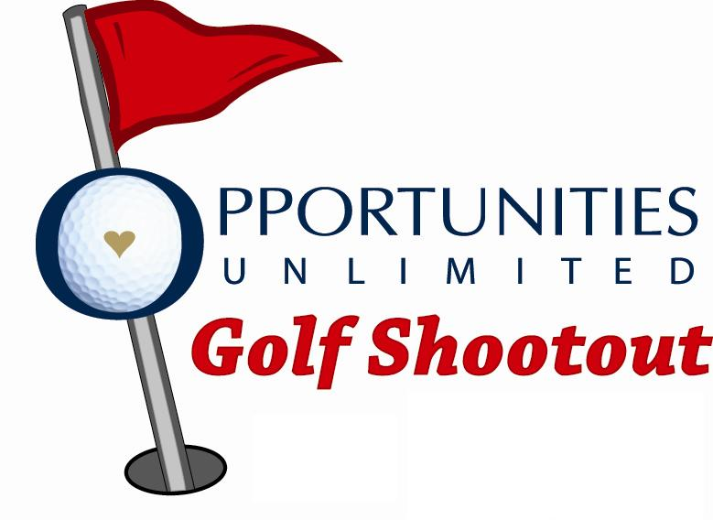
26th Annual OU Golf Shootout Sponsorship Form
Friday, July 21st, 2023, Sioux City Country Club

Sponsorship Level | Payment Enclosed
Title Level: $10,000 | Y/N
Eagle Level: $5,000 | Y/N
Cart, Lunch, or Dinner Sponsor: $3,000 | Y/N
Birdie Level: $1,700 | Y/N
Contest Sponsor: $1,000 | Y/N
Par Level: $700.00 | Y/N
Tees/Greens Sponsor:  $250.00 each | Y/N

NAME/COMPANY: _________________________________________

ADDRESS: _________________________________________________

PHONE : ___________________________________________________

EMAIL: ____________________________________________________

CONTACT PERSON: ________________________________________

Please return this form to Susan Vondrak at 3439 Glen Oaks Boulevard
Sioux City, IA 51104, or fax (712) 277-8602 or email svondrak@opportunitiesunlimited.com

